Diane’s Biscuits
These drop biscuits make great burger buns or holiday rolls. Also awesome with honey, butter, jam, and even sausage and gravy!

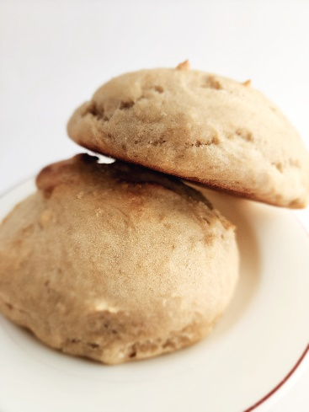
1 1/3 cup Warm Water
1 packet Instant Yeast (2.25 tsp)
1/3 cup Oil
1/4 cup Sugar
3 ½ cups Flour
1 tsp Salt

Preheat oven to 425 degrees, and grease or line a baking sheet with parchment.
In a large bowl combine warm water, yeast, oil, and sugar. Use a whisk to mix well and then leave in a warm spot for 15 minutes. The yeast should puff up slightly.
Once yeast looks poofy, add the salt, and whisk once more before adding flour. Mix in flour really well, until completely incorporated.
Scoop the dough onto your prepared baking sheet, creating 8-10 rounded biscuits. Leave them alone in a warm spot for 10 minutes before baking. They may not rise much during this time, but it give the yeast time to make good friends with the flour.
Bake for at least 10 minutes or until the pointy bits on the top of the biscuits begin to turn golden. The bottoms should be golden as well.
Let cool for 15 minutes before slicing, if using for burger buns.

Notes: I always use unchlorinated water in any bread recipe to help yeasts work more efficiently, and I always use Olive Oil whenever oil is called for. Avocado Oil is another healthy choice. Tailor the size of your biscuits for your needs – make fewer larger ones for big burgers, or more small ones for morning pick me ups with jam. Just be sure to adjust the time if playing with different sized biscuits.

